

Dr. Jacob, Davis inc.
2018-04-21
Dr. Davis
Unit 9546 Box 2569, DPO AA 45070
Phone: 4885176057
Fax: 704185518

Re: Sylvia, Evans
PHN: 5701004944
Birthdate: 22-Aug-1948
Address: 15537 Li Stream Suite 402, South Michael, SD 78955
Patient number: 6750463382

To Whom It May Concern:

This is a medical letter to state the above patient is pregnant with expected delivery date of 12-Aug-2025. Hoping this information is satisfactory for your requirements.

Thank you.

Sincerely,
Dr. Jacob, Davis
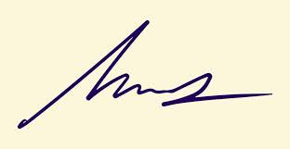
FRCS© NCMP
Clinical Assistant Professor, UBC
Department of Obstetrics and Gynecology SMH

